Ventura College Academic Senate
Survey on Faculty Professional Satisfaction
Spring 2011
Overview
During the last few weeks of the spring 2011 semester, the Ventura College Academic Senate Executive Committee developed and conducted a survey of all full- and part-time faculty to gauge the temperature of professional life and satisfaction at Ventura College. This marks the second consecutive spring semester when the Ventura College Academic Senate has conducted a survey of this sort. The survey was modeled after an instrument originally distributed in the fall of 2009 to Moorpark College faculty by their Academic Senate that was then replicated (with some modifications) by the Ventura College Academic Senate in spring 2010. This year’s iteration of the survey consisted of a series of questions in three main categories: 1.) Professional Level of Satisfaction; 2.) Professional Level of Satisfaction Today vs. Previous Year; 3.) Ventura College Mission Statement. Over 80 faculty began the survey and over 75 completed it, a close to 93% completion rate (82/76 = 92.7%). Given anecdotal experience with past faculty surveys, this is a very high response rate although not as high as last year’s survey when over 120 faculty began the survey and close to 110 completed it. The decline in responses may be attributed to the fact that this survey went out two weeks later this year than last year.
1. Professional Level Satisfaction
In this first area of the survey, faculty were asked to rate their state of being in the following areas: Energized, Effective, Satisfied, Appreciated, Frustrated, Stressed, and Resentful. Generally, Ventura College faculty responded that they either agreed or strongly agreed that they felt effective, stressed and frustrated, in that ranked order (52/77; 47/77; 41/77 responses, respectively). In the categories of energized and satisfied, responses were either evenly divided or almost evenly divided between the “agree/strongly agree” and “disagree/strongly disagree” choices with a sizable amount of respondents selecting “neutral” for these two categories. In an interesting development when compared to last year’s survey, respondents noted in equally measure that either feel “neutral” or “strongly disagree” with the statement that they are appreciated at Ventura College; when one tallies the responses for both “disagree” and “strongly disagree” in this category, more faculty do feel unappreciated than appreciated at VC, however. This is an interesting and disturbing increase from last year’s survey. Lastly, a sizable minority of respondents (22/77) indicated that they either “agree” or “strongly agree” that they do not feel resentful.
2. Professional Level of Satisfaction Today vs. Previous Year
This second area of the survey asked faculty to gauge their state of being in the same seven categories listed in Question 1 but to compare their feelings from this academic year to last academic year. Faculty clearly indicated that they feel both less energized and more stressed this year than they did last year. This is a partial change from last year when faculty noted that they felt both less energized and satisfied. Once again similarly to last year’s survey results, while 35 out of 76 respondents noted that they felt “no change” in how appreciated they are, an almost equal amount (31) noted that they feel less appreciated now than this time last year. Similarly, while a slight majority of respondents (31/76) indicated they felt “no change” in how frustrated they are, a significant minority (28/76) indicated that they feel more frustrated this year. Faculty also indicated “no change” in how stressed and resentful they feel now compared to last year. In a change from last year’s survey, more faculty respondents indicated that they feel higher stress levels now than they did in the past (32 out of 77 respondents). Given the changes that have occurred this year (e.g., accreditation, student learning outcomes, budget constraints, etc.), one might find it surprising that the number of respondents who feel more stressed this year when compared to last year is not greater. Lastly, and perhaps most importantly, despite decreased energy and satisfaction levels, it is vital to note that faculty feel that their effectiveness has not changed at all since last year (48/77 respondents felt “no change” in this category).

3. Ventura College Mission
This section of the survey broke down the Ventura College Mission Statement into 14 separate questions and asked faculty members to provide a Yes/No/Don’t Know response on if “in your opinion…the college [is] meeting [the] individual goals as stated in the [institution’s] mission statement.” In all cases save one notable exception for experiential learning courses, the respondents indicated that the college was fulfilling its stated mission. While the respondents did indicate that overall the institution was meeting the goals put forth in the adopted mission statement, for several parts of the mission statement (i.e., questions 5, 11, 12, 13) the large number of “don’t know” responses—even when these “don’t know” do not constitute a majority of the responses gathered—may indicate a need for the institution to either better identify and/or define what these statements in our mission statement mean or better publicize what these programs and services are to the campus community.
Conclusion
The first two parts of this survey do bring to light some plusses and minuses of the college. It is comforting to note that no matter the external and internal challenges that may face us, faculty remain confident in the perception of our effectiveness in the classroom, lab, athletic field, performance stage, counseling office or library. It is also worthy to note that faculty feel stressed, frustrated, under-appreciated. When compared to last year at this time, faculty also less energized. In order to remain a top quality state supported post-secondary institution of higher learning, Ventura College should take effective steps to ensure that faculty continue to feel effective, become more energized and not so stressed, frustrated or under-appreciated.

Addendum: Actual Survey Results
Part 1.
Question 1.
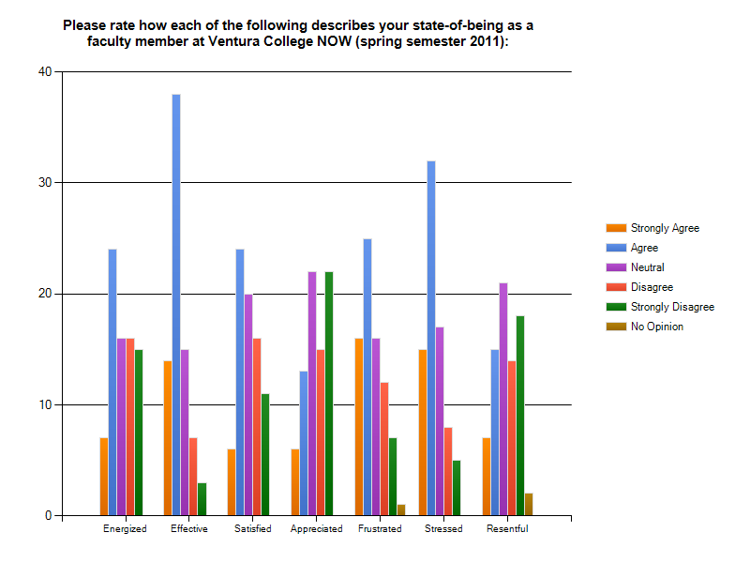

Part 2.
Question 1.
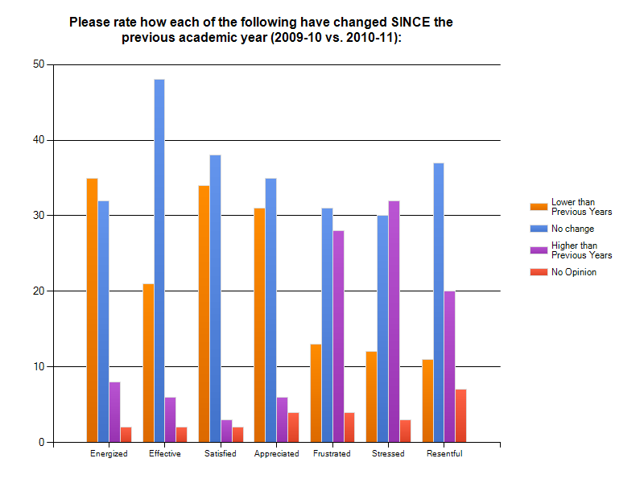

Part 3.
Question 1.
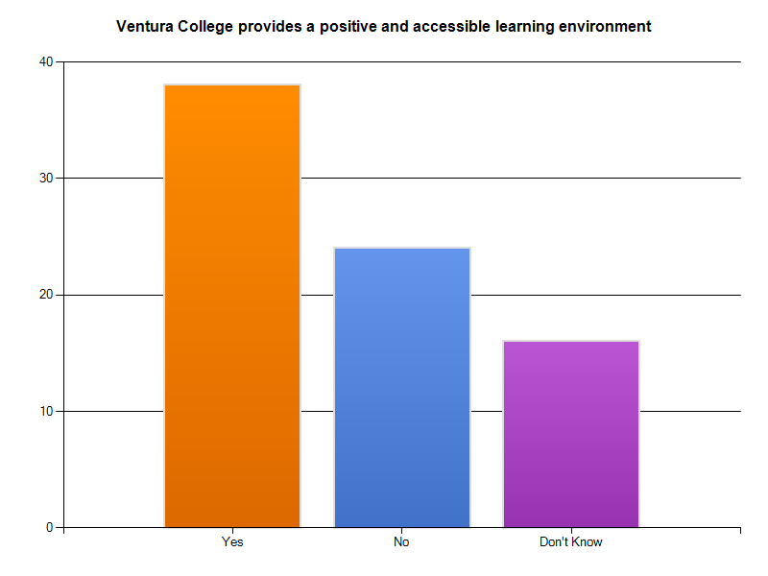
Question 2.
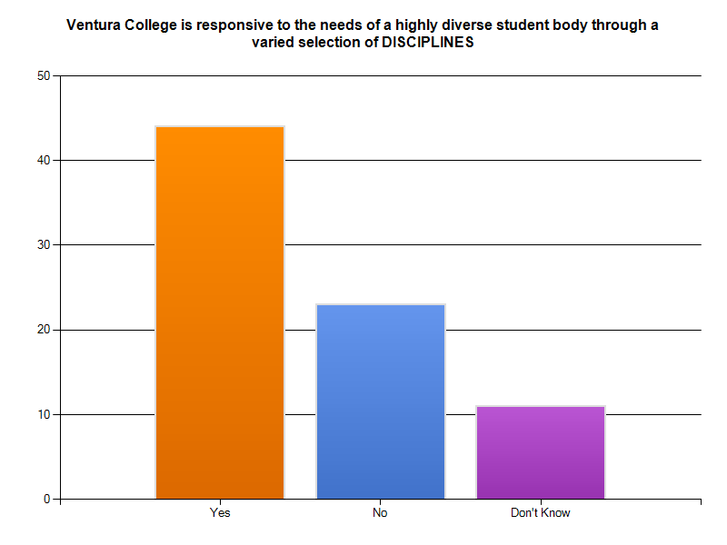

Question 3.
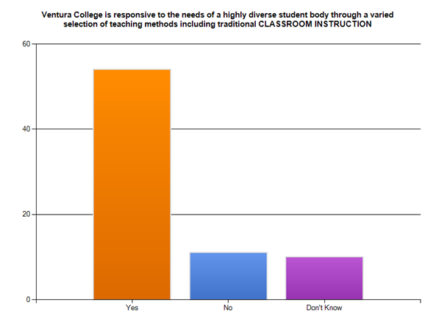

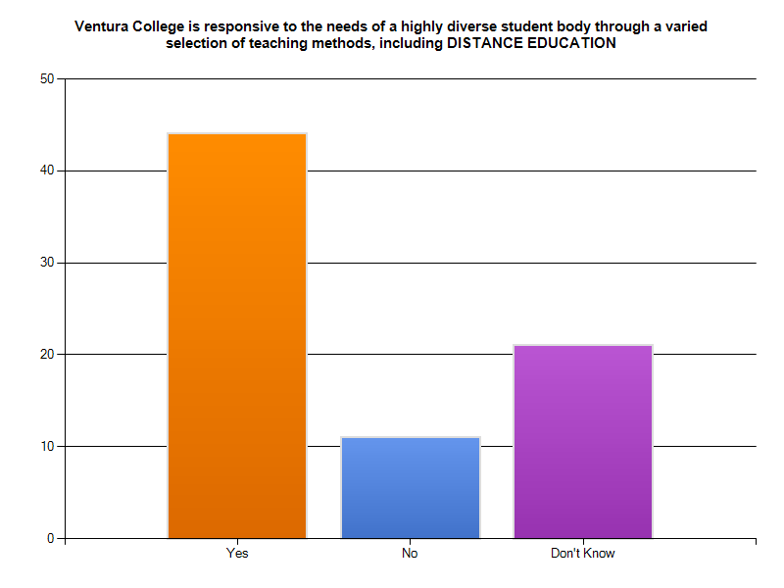
Question 4.

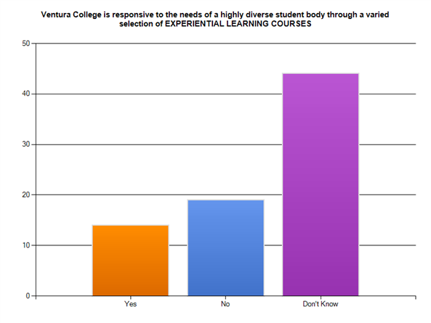
Question 5.

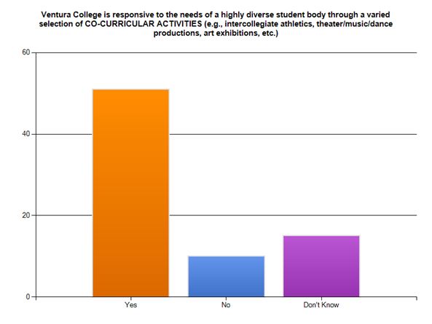
Question 6.

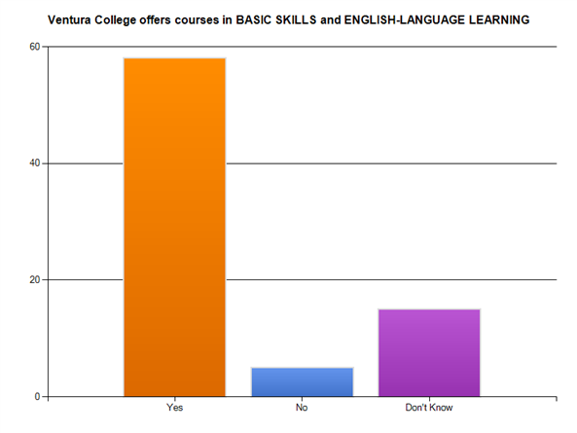
Question 7.

Question 8.
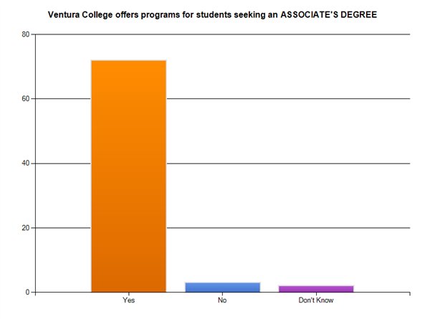

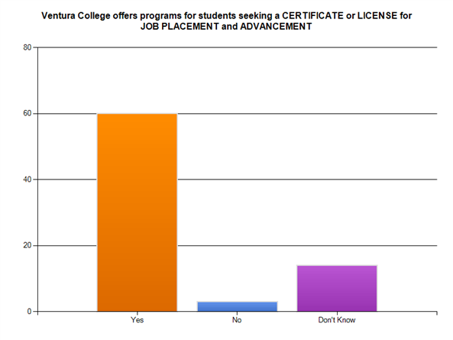
Question 9.

Question 10.
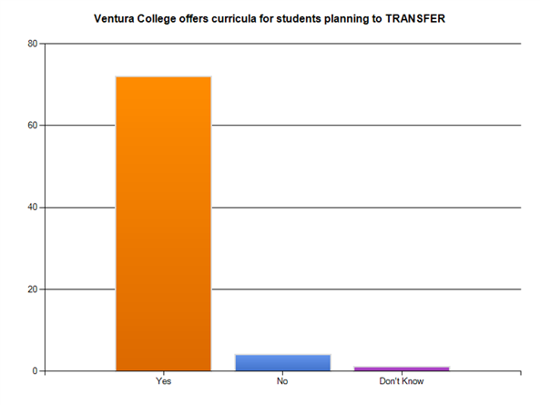

Question 11.
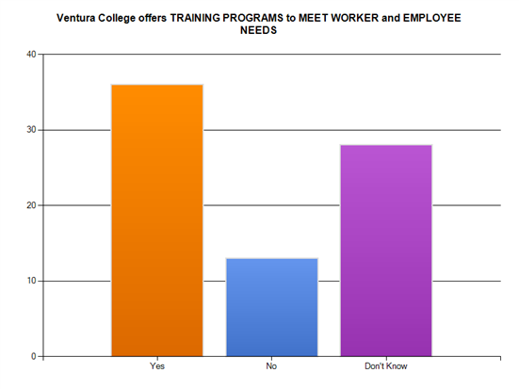

Question 12.
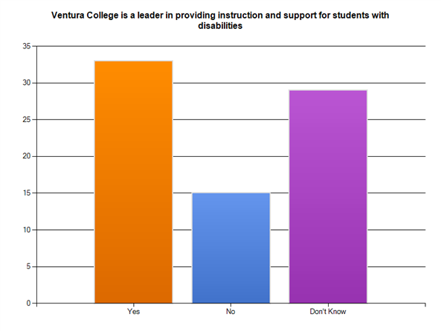

Question 13.
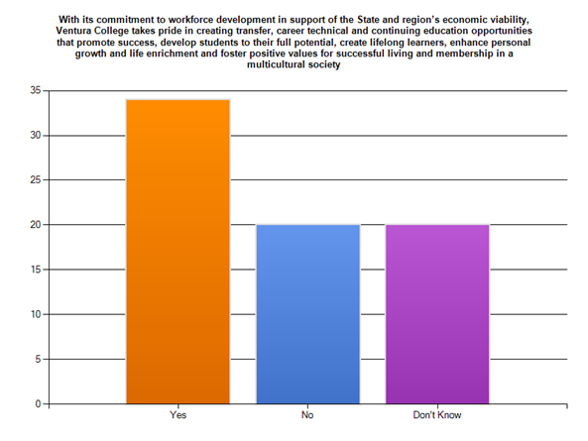

Question 14.
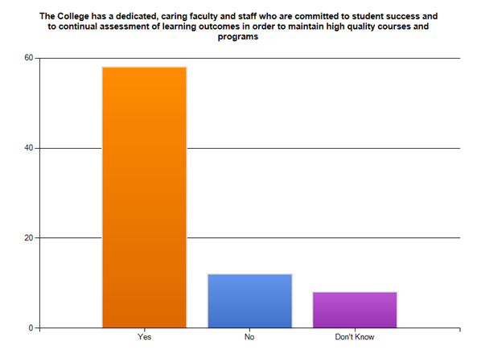

Demographics.
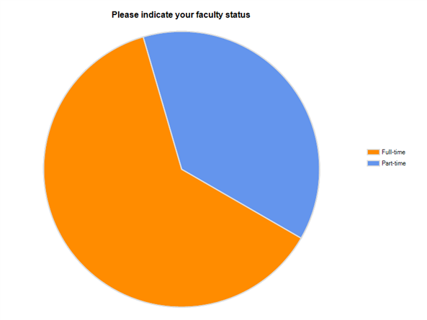
Question 1.

Question 2.

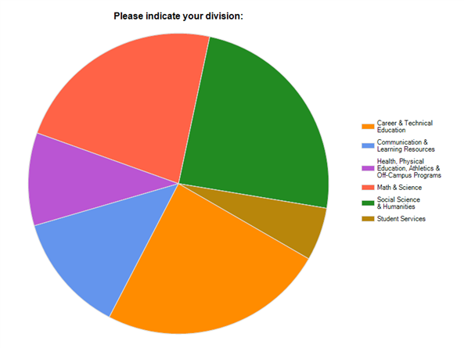

Question 3.
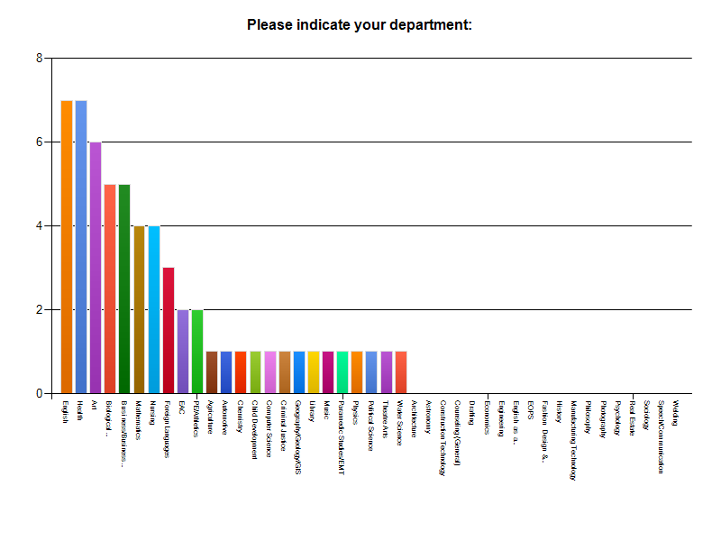
Question 4.
